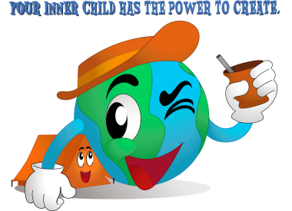
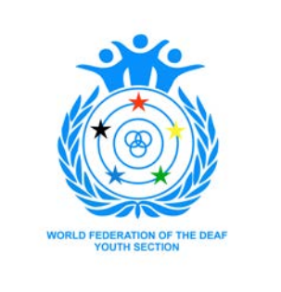
First Announcement

Dear Deaf Youth Associations / Sections and/or Deaf Associations

It is a huge pleasure to announce that WFDYS Camp Organizing Committee from the country Argentina will be responsible for organizing to host World Federation of the Deaf Youth Section 4th Children Camp to be held in South America in the city Buenos Aires, Argentina, 8th April - 14th April 2018.

The objectives of our camp are: to provide leadership training for deaf youth and deaf children in multiple activities; encourage the connection between deaf youth and deaf children from different countries, to develop and / or improve their sense of pride and acceptance of their identity; support for cultural exchanges between different nationalities.

We accomplish to achieve this through our motto “Your inner child has the power to create”
Every child is different because of its spontaneity, creativity, enthusiasm, happiness, imagination and fulfillment. We are committed to ensuring that this will be the most successful and affordable camp for all the countries involved.

The registration fee is 350 € per person applies to the all participants and leaders. This fee will cover your accommodation, meals, local transportation, trainings, workshops, activities and resource materials.

Any participants or leaders are interested to attend the camp, please contact your Deaf Youth Associations / Sections and/or Deaf Associations. We will only accept to receive the registration and applications forms through Deaf Youth Associations / Sections or Deaf Associations. The individual application submission will be not accepted. The deadline for registration and applications forms will be on 1st November 2017.

We will accept first two participants out of four participants and one leader from each country however if we can accept a further number of applications, we will be asking each country to submit more participants.
Please see below in this document for further information:

- Tentative program 5. Leader Application Form
- Country list 6. Flights Information
- Deaf Assoc. / Deaf Youth Assoc. Registration Form 7. Visa Information
- Camper Application Form 8. Payment details

If you require more information or have any question, please do contact us anytime. We look forward to receiving applications by 1st November 2017.

Warm regards,

Florencia Laurence
Camp Coordinator

wfdysch2018@gmail.com | 4th WFDYS Children Camp – 2018
4th WFDYS Children Camp | wfdysch2018
http://dj.cas.org.ar/camp2018/

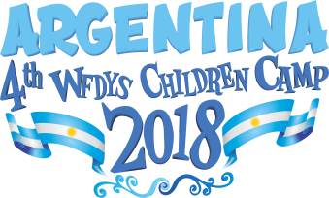
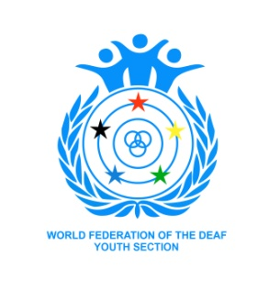

WFDYS COC reserves the rights to change program at any time, without any notice.

 | Sunday 8 | Monday 9 | Tuesday 10 | Wednesday11 | Thursday 12 | Friday 13 | Saturday 14
09:00 | Arrival Day | Breakfast | Breakfast | Breakfast | Breakfast | Breakfast | Breakfast
10:00 | // // | International Sign Presentation/Workshop | Workshop | Workshop | Workshop | Tour (Parque de la Costa) | TBC
11:00 | Arrival Day |  |  |  |  |  | TBC
12:00 |  |  |  |  |  |  | TBC
13:00 | // // | Lunch | Lunch | Lunch | Lunch | Lunch | Lunch
14:00 | Icebreaker Activity | Presentation by WFDYS and COC | Tour | Tour (Deaf place) | Activity (Olympic Sport) | Tour (Parque de la Costa) | TBC
15:00 |  | Activity (integration game) |  |  |  |  | TBC
16:00 | Opening Ceremony |  |  |  |  |  | Departure Day
17:00 |  | Cultural Evening | Art and Theater | Activity | Entertainment | Group Points Game
18:00
19:00 | Dinner | Dinner | Dinner | Dinner | Dinner | Closing Ceremony
20:00
21:00 | Sleep Time | Sleep Time | Sleep Time | Sleep Time | Sleep Time | Sleep Time
22:00 | COC/Leaders Meeting | COC/Leaders Meeting | COC/Leaders Meeting | COC/Leaders Meeting | COC/Leaders Meeting | COC/Leaders Meeting

wfdysch2018@gmail.com | 4th WFDYS Children Camp – 2018
4th WFDYS Children Camp | wfdysch2018
http://dj.cas.org.ar/camp2018/

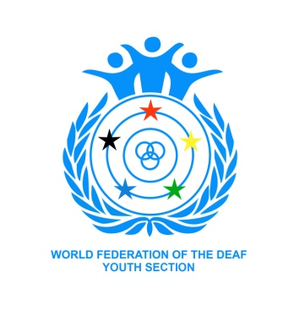  Zone A: 350 EUROS | COUNTRY LIST

Albanian  Algeria  Argentina  Australia  Austria  Azerbaijan  Belarus  Belgium  Bosnia & Herzeg.  Brazil  Bulgaria  Canada  Chile  China  Colombia  Costa Rica  Croatia  Cuba  Cyprus  Czech Republic  Denmark  Dominican  Ecuador  Estonia  Zone B: 300 EUROS | Fiji  Finland  France  Germany  Greece  Hong Kong  Hungary  Iceland  Iran  Ireland  Israel  Italy  Japan  Kazakhstan  Korea, South  Kuwait  Latvia  Libya  Lithuania  Macau  Macedonia  Malaysia  Mali  Malta | Mexico  Netherlands  New Zealand  Norway  Panama  Peru  Poland  Portugal  Qatar  Romania  Russia  Serbia  Singapore  Slovakia  Slovenia  Spain  Sweden  Switzerland  Thailand  Tunisia  Turkey  United Kingdom  Uruguay  USA  Venezuela
Afghanistan  Armenia  Bangladesh  Benin  Bolivia  Botswana  Burkina Faso  Burundi  Cameroon  Chad  Congo Dem.Rep  Congo Rep. Of  Cote d’ Ivoire  El Salvador  Eritrea  Ethiopia  Gambia  Georgia  Ghana  Guatemala | Guinea  Honduras  India  Indonesia  Kenya  Lesotho  Liberia  Madagascar  Malawi  Mauritania  Moldova  Mongolia  Morocco  Mozambique  Namibia  Nepal  Nicaragua  Niger  Nigeria  Pakistan | Paraguay  Philippines  Rwanda  Senegal  Sierra Leone  Somalia  South Africa  Sri Lanka  Sudan  Swaziland  Syria  Tajikistan  Tanzania  Togo  Uganda  Ukraine  Uzbekistan  Zambia  Zimbabwe
If your country is not on the list, please contact with your country’s National Deaf Youth Association / Section or Deaf Association to check with World Federation of the Deaf regarding its status on being an Ordinary Member/Youth Ordinary Member.
wfdysch2018@gmail.com | 4th WFDYS Children Camp – 2018
4th WFDYS Children Camp | wfdysch2018
http://dj.cas.org.ar/camp2018/

REGISTRATION FORM
Na t i o nal D eaf Yout hSection or Association / D eaf A s s oc i at i on

Association:

Address:

Country:

Fax: Email:

YOUTH ORDINARY MEMBER: [ ] Y E S [ ] N O

CAMP PARTICIPANTS
Leader 1 | _____________________________________________
Leader 2 (RESERVE) | _____________________________________________
Camper 1 | _____________________________________________
Camper 2 | _____________________________________________
Camper 3 (RESERVE) | _____________________________________________
Camper 4 (RESERVE) | _____________________________________________

(If there are available spots after the deadline, your country can send more participants)

(BANK TRANSFER INFORMATION)
Once the registration applications are completed, (Before 1st November 2017) and payments are made, please scan each page and email wfdysch2018@gmail.com in PDF Version. Please attach the receipt of your payment transaction, a passport style individual photo of each participant and leader. All leaders must attach a photocopy of their passport to their application.

Date:

OM/YOM President or Secretary Name:

OM/YOM President or Secretary Signature:

CAMP 1
APPLICATION FORM

Full Name: _______________________________________________________________________

Photo
4 x4

Date of Birth (dd/mm/yy): ______________________ Gender: [ ] Male [ ] Female

Address: _________________________________________________________________________

Postal code: _____________________________________________________________________

Country: ___________________________________________________________________

Email: SMS: __________________________
(Include your country area code)

Dietary Requirements (please circle):
N/A Halal Gluten Free Lactose / Dairy Free Vegetarian
Other:
Allergies:
Medications:
Other important information (please specify):
T-Shirt Size (Please circle): SMALL MEDIUM LARGE X-LARGE Other:
Emergency Contact Name:
SMS / Email:
Date: Parent / Guardian Signature:
Date: YOM/OM President or Secretary Signature:

**Please also attach a passport style individual photo on this application

*All forms must be completed and camp fees paid by 1 November 2017*

CAMP 2
APPLICATION FORM

Full Name: _______________________________________________________________________

Photo
4 x4

Date of Birth (dd/mm/yy): ______________________ Gender: [ ] Male [ ] Female

Address: _________________________________________________________________________

Postal code: _____________________________________________________________________

Country: ___________________________________________________________________

Email: SMS: _________________________
(Include your country area code)

Dietary Requirements (please circle):
N/A Halal Gluten Free Lactose / Dairy Free Vegetarian
Other:
Allergies:
Medications:
Other important information (please specify):
T-Shirt Size (Please circle): SMALL MEDIUM LARGE X-LARGE Other:
Emergency Contact Name:
SMS / Email:
Date: Parent / Guardian Signature:
Date: YOM/OM President or Secretary Signature:

**Please also attach a passport style individual photo to this application

*All forms must be completed and camp fees paid by 1 November 2017*

CAMP 3 (RESERVE)
APPLICATION FORM

Full Name: _______________________________________________________________________

Photo
4 x4

Date of Birth (dd/mm/yy): ______________________ Gender: [ ] Male [ ] Female

Address: _________________________________________________________________________

Postal code: _____________________________________________________________________

Country: ___________________________________________________________________

Email: SMS: __________________________
(Include your country area code)

Dietary Requirements (please circle):
N/A Halal Gluten Free Lactose / Dairy Free Vegetarian
Other:
Allergies:
Medications:
Other important information (please specify):
T-Shirt Size (Please circle): SMALL MEDIUM LARGE X-LARGE Other:
Emergency Contact Name:
SMS / Email:
Date: Parent / Guardian Signature:
Date: YOM/OM President or Secretary Signature:

**Please also attach a passport style individual photo to this application

*All forms must be completed and camp fees paid by 1 November 2017*

CAMP 4 (RESERVE)
APPLICATION FORM

Full Name: _______________________________________________________________________

Photo
4 x4

Date of Birth (dd/mm/yy): ______________________ Gender: [ ] Male [ ] Female

Address: _________________________________________________________________________

Postal code: _____________________________________________________________________

Country: ___________________________________________________________________

Email: SMS: ________________________
(Include your country area code)

Dietary Requirements (please circle):
N/A Halal Gluten Free Lactose / Dairy Free Vegetarian
Other:
Allergies:
Medications:
Other important information (please specify):
T-Shirt Size (Please circle): SMALL MEDIUM LARGE X-LARGE Other:
Emergency Contact Name:
SMS / Email:
Date: Parent / Guardian Signature:
Date: YOM/OM President or Secretary Signature:

**Please also attach a passport style individual photo to this application

*All forms must be completed and camp fees paid by 1 November 2017*

LEADER 1
APPLICATION FORM

Full Name: _______________________________________________________________________

Photo
4 x4

Date of Birth (dd/mm/yy): ______________________ Gender: [ ] Male [ ] Female

Address: _________________________________________________________________________

Postal code: _____________________________________________________________________

Country: ___________________________________________________________________

Email: SMS: __________________________
(Include your country area code)

Dietary Requirements (please circle):
N/A Halal Gluten Free Lactose / Dairy Free Vegetarian
Other:
Allergies:
Medications:
Other important information (please specify):
T-Shirt Size (Please circle): SMALL MEDIUM LARGE X-LARGE Other:
Emergency Contact Name:
SMS / Email:
Date: Parent / Guardian Signature:
Date: YOM/OM President or Secretary Signature:

**Please also attach a passport style individual photo to this application

*All forms must be completed and camp fees paid by 1 November 2017*

LEADER 2 (RESERVE)
APPLICATION FORM

Full Name: _______________________________________________________________________

Photo
4 x4

Date of Birth (dd/mm/yy): ______________________ Gender: [ ] Male [ ] Female

Address: _________________________________________________________________________

Postal code: _____________________________________________________________________

Country: ___________________________________________________________________

Email: SMS: __________________________
(Include your country area code)

Dietary Requirements (please circle):
N/A Halal Gluten Free Lactose / Dairy Free Vegetarian
Other:
Allergies:
Medications:
Other important information (please specify):
T-Shirt Size (Please circle): SMALL MEDIUM LARGE X-LARGE Other:
Emergency Contact Name:
SMS / Email:
Date: Parent / Guardian Signature:
Date: YOM/OM President or Secretary Signature:

**Please also attach a passport style individual photo to this application

*All forms must be completed and camp fees paid by 1 November 2017*

FLIGHTS
INFORMATION

CAMP PARTICIPANTS
Leader 1 | _____________________________________________
Leader 2 (RESERVE) | _____________________________________________
Camper 1 | _____________________________________________
Camper 2 | _____________________________________________
Camper 3 (RESERVE) | _____________________________________________
Camper 4 (RESERVE) | _____________________________________________

Airport: Aeropuerto Internacional Ministro Pistarini (Ezeiza) // Aeroparque Internacional Jorge Newbery

Arrival - 8th of April 2018

Flight number: ______________________________________

Airline: __________________________
Time: ________________

Departure - 14th of April 2018

Flight number: ___________________________________

Airline: __________________________
Time: _________________

*All forms must be completed and camp fees paid by 1 November 2017*

VISA INFORMATION
We recommend that you contact the Argentina Embassy in your country to find out the requirement of visa you need to apply. The visa application may vary from your country compare to other country. If you research about the visa on internet, make sure select your country from the list and to check if it is required to apply the visa and may pay the visa fees.

Please contact us if you need any further information regards to the visa application or status below:

Contact person: Florencia Laurence, Camp Coordinator

Mobile: +5491140912210 (Whatsapp/SMS/iMessage)

Address of our deaf association: Yerbal 176, C1405CDD, Buenos Aires, Argentina

Email: wfdysch2018@gmail.com

wfdysch2018@gmail.com | 4th WFDYS Children Camp – 2018
4th WFDYS Children Camp | wfdysch2018
http://dj.cas.org.ar/camp2018/

PAYMENT DETAILS
Please ensure that the payment is completed soon as the forms are being submitted.
We require the payment to be paid fully per the National Deaf Youth Association/Section or Deaf Association include all participants and the leader. In case this is not possible from your end, please contact us to discuss the alternative options.

Important notice: We are not responsible for any international or bank fees that may incur. We are not responsible for the loss of proof of transfer.
BANK TRANSFER: BANCO DE LA CIUDAD DE BUENOS AIRES
ACCOUNT NAME: CONFEDERACION ARGENTINA DE SORDOMUDOS
CUIT: 33643383549
ACCOUNT NUMBER: 000001110000132624
CBU: 0290000100000001326246

We suggest that you keep record of the remittance/transfer receipt number in case of any issue with payment process. Please complete the form below and email to us once the payment is completed.

Deaf Association/Deaf Youth Association:

Email:

Campers paid for:
Total amount: EURO

Leader paid for:
Total amount: EURO

Total:

Payment method: BANK TRANSFER

Paid on:

Thank you, we will get in touch with you to confirm the registration & payment soon as possible! We look forward to having your selected participants & leader with us during 4th WFDYS Children Camp in April 2018!

wfdysch2018@gmail.com | 4th WFDYS Children Camp – 2018
4th WFDYS Children Camp | wfdysch2018
http://dj.cas.org.ar/camp2018/

